**Title:** Laboratory 2 Molecular Activity and Membrane Transport

Purpose: To investigate the basic properties of passive transport including diffusion, osmosis, and differential permeability. The concept of filtration and the effects of tonicity on cells will also be explored.

**Procedure**

**2-B: Measurement of Diffusion through a liquid**

1. Working in groups, fill three Petri dishes with 40 ml. of 25°C water.
2. Drop one crystal of potassium permanganate into each dish. Be sure to use the same amount of potassium permanganate for each dish. Record the time.
3. Measure, in millimeters, and record the largest diameter of the colored spot after 5minutes.
4. Repeat steps 1-3 for water at 5°C and at 45°C.
5. Construct a graph of ranges and means for each temperature.
6. Based on your knowledge of diffusion, what is an explanation for these results?

**2-C: Measurement of diffusion through agar**

1. Petri dishes have been filled with agar. Two holes have been made in the agar. Into one hole, place two drops of methylene blue. Into the other hole, place two drops of potassium permanganate. Record the time and immediate diameter of each spot. This will be your time zero measurement.
2. Measure the diameter of each spot in millimeters once every minute for fifteen minutes. Calculate the averages from the data collected by all groups doing this exercise. Summarize these data.
3. Construct a graph of average diffusion diameter versus time for both chemicals.
4. Determine the diffusion rate of each chemical. Which has the fastest diffusion rate, methylene blue or potassium permanganate? Record these results.
5. Look up the molecular formula and structure of methylene blue and potassium permanganate in a Merck Index. Make note of this information.
6. Interpret your result with respect to the information obtained from the Merck Index.

**2-D: Demonstration of filtration**

1. Fold three filter papers into cones and insert them into three separate glass funnels. Wet the papers to make them stick to the glass.
2. Prepare three 100-milliliter solutions of charcoal and water. Make one thick, one medium thickness, and one thin. Record the mass of the charcoal used in each preparation.
3. NOTE: if your “thin” solution continually runs through the filter, making it impossible to count drops, it is too thin; you will need to make all your solutions proportionally thicker.
4. Pour 50 ml of each solution, one at a time, into a funnel.
5. Immediately count the number of drops produced per minute.
6. NOTE: it may be easier to count the drops for 15 seconds then multiply by four to obtain drops per minute.
7. Count the number of drops per minute when the funnel is half-filled
8. Count the number of drops per minute when the funnel is nearly empty.
9. Did the charcoal pass into the filtrate? Which solution had the fastest rate of filtration? What is the driving force behind filtration? What other factors influence the rate of filtration? Do your results illustrate these influencing factors?
10. Repeat these procedures with the remaining 50 ml. of solution.

**2-F: Measurement of osmosis**

1. Attach dialysis bags filled as much as possible with sucrose solutions securely to the bottom of two open, thin glass tubes. One bag should be filled with a25% sucrose solution and the other should be filled with a 50% sucrose solution. Make sure ends of the tubes are immersed in the solutions.
2. NOTE: reliable results depend on your ability to tightly seal the dialysis bags.
3. Insert both bags into separate beakers of distilled water making sure the dialysis bags are fully submersed but not touching the bottom of the beakers, and suspend each by gently applying a ring stand clamp to the glass tubes. Check for solution leaking out of the bags.
4. Allow five minutes for the systems to equilibrate. Then, mark the fluid levels of each glass tube with a felt pen. Record the time.
5. Record the fluid level of the glass tubes in millimeters every 10 minutes for 50 minutes.
6. 5.If the fluid level rises to the top of the glass tube sooner than 50 minutes, record the time it took to get there, measure the length in millimeters from the equilibration line to the top of glass tube. Divide that length by the number of minutes to get your rate in mm/min.
7. Determine the rate of osmosis for each system. Which system had the fastest osmotic rate, the 25% or 50% sucrose solution? Explain these results.

**2-G Measurement of differential permeability of sugar and starch**

1. Fill a dialysis bag with a 1% starch–10% glucose solution. Reliable results depend on your ability to tightly seal the dialysis bag.
2. Tie the bag to a glass rod and suspend it in a beaker of distilled water.

NOTE: Test the water from the bottom of the beaker to ensure that it is free of starch and/or sugar.

1. After 15 minutes has passed check the water again for starch and sugar in the following way:

Test for starch:

1. Add 10 drops of Lugol’s solution to 5 ml of water obtained from the beaker.

Reddish color = No starch

Navy blue color = Starch present

Test for sugar:

1. Add 3 ml of Benedict’s solution to 5 ml of water obtained from the beaker.

Simmer the solution at a low boil for 5 minutes.

Blue color = No sugar

Color change = Sugar present (green = little sugar; yellow =moderate sugar; orange = more sugar; red = lots of sugar)

1. Test the water in the beaker again at 30, 45 and 60 minutes.
2. Record these results. Explain the significance of these findings in relation to the permeability of the dialysis bag.

**2-H: The effects of tonicity on red blood cells- demonstration**

1. 1. One milliliter of each of the following solutions will be in three separate test tubes.

a. Distilled water (hypotonic)

b. Physiological saline–0.85% NaCl (isotonic)

c. Salt water–2.0% NaCl (hypertonic)

1. A small drop of blood will be added to each tube and the contents thoroughly mixed.
2. A wet mount slide will be made of each solution.
3. Examine each slide under the high-dry lens of a compound microscope.
4. Observe the following:

a. Hemolysis of cells in the hypotonic solution. (Note the transparent solution.)

b. Maintenance of cell size in the isotonic solution.

c. Crenation of cells in the hypertonic solution.

6. Make a drawing of each observation and provide an explanation for each.

**Results:**

**2B**

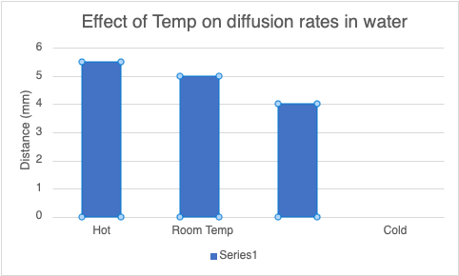

**2C**

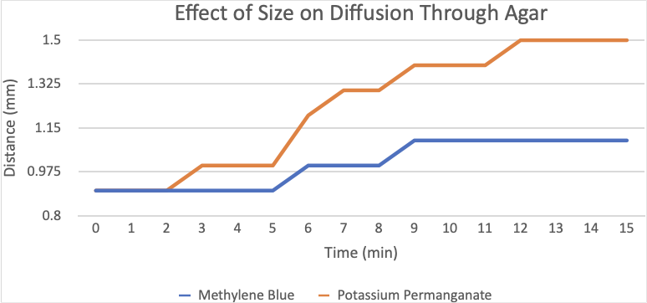

**2D**

|  |  |  |  |
| --- | --- | --- | --- |
| **Charcoal** | **Light** | **Medium** | **Thick** |
|  | 14.40g | 16.53g | 20.04g |
| 1 minute | 176 | 160 | 160 |
|  | 40 | 32 | 32 |
|  | 12 | 24 | 24 |
| 2 minutes | 168 | 112 | 160 |
|  | 40 | 44 | 24 |
|  | 12 | 20 | 16 |

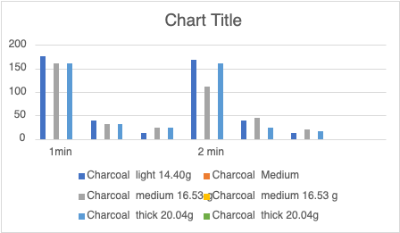

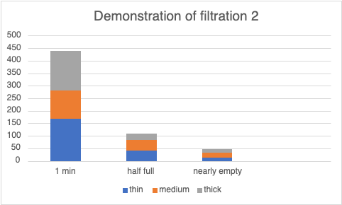

**2F**

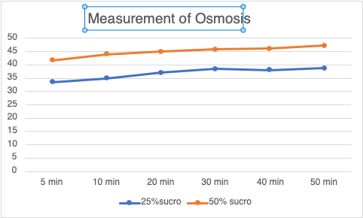

**2G**

|  |  |  |  |  |
| --- | --- | --- | --- | --- |
|  | **15 min** | **30 min** | **45 min** | **60 min** |
| **Sugar** | 0 | Moderate | More Sugar | More Sugar |
| **Starch** | 0 | 0 | 0 | 0 |

**Discussion**

With this laboratory we were able to learn more about how osmosis, diffusion and filtrations works.

**Conclusion**

Diffusion refers to the movement of molecules from an area of high concentration. Osmosis is a type of diffusion specifically for water molecules moving across semi-permeable membrane. Filtration is the removal or filtering of the toxins and waste products from the blood by the kidney. Filtration refers to the passing of a liquid through a filter. Like in the human body the kidney functions as a filter.